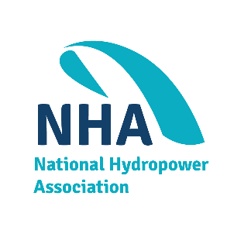

Future Leaders of Waterpower (FLOW) Call: November 18, 2021

Overview
Microsoft Teams Meeting
Join on your computer or mobile app
Click here to join the meeting

Or call in (audio only)
+1 469-253-5858,,357816607# United States, Dallas

Phone Conference ID: 357 816 607#
Find a local number | Reset PIN
Learn More | Meeting options
FLOW had a great launch last month at NHA’s inaugural Clean Currents! Riding the momentum, this month’s FLOW call will focus on some major topics: a 101 introduction on how a bill becomes a law, the NHA Board of Directors, and career-advancement skills.

As a reminder, voting is open for the NHA Board of Directors. If you are an employee of an NHA member organization, you are an eligible voter! Contact Marycella to learn more.

Agenda
- Opening Remarks from Leadership | Elliott Jackson, HDR

- How Does a Bill Become a Law? A Crash Course in the Legislative Process | Zolaikha Strong, NHA

- Election Season: Who are the NHA Board of Directors and Why They Matter | Jeff Leahey, Strategic Marketing Innovations

- Career Corner: Leveraging Professional Associations (like NHA) to Further Your Career | Michael Rogers, Stantec

- FLOW Member Opportunities: An Open Forum for FLOW Group to Share | Moderator: Nuria Holmes, Kleinschmidt
  - LinkedIn Group
  - FLOW Members should feel free to share: Is your organization hiring? Did you hear about a free webinar? Is there something you learned that you want to share? Did you recently attend an NHA event (and how did it go)?

- Closing Remarks | Elliott Jackson, HDR

